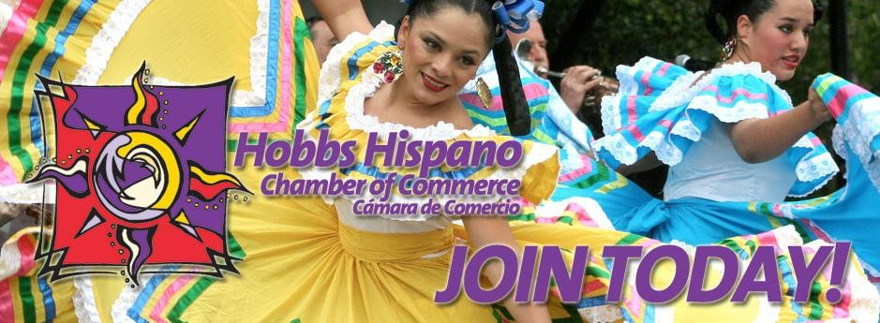

2019 HOBBS HISPANO CHAMBER OF COMMERCE
INFORMATION PACKET

WELCOME

It is with great pleasure that I introduce you to the Hobbs Hispano Chamber of Commerce.

“The Mission of the Hobbs Hispano Chamber of Commerce is the formation of strategic partnerships to support the development and growth of small businesses and provide guidance to potential entrepreneurs in Lea County.”

Many businesses in the Lea County area have found the value of membership in the Hobbs Hispano Chamber of Commerce. I hope that you will take a few minutes to consider what we can do for you and your business.

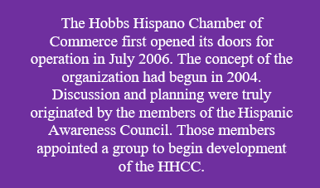

Our Contribution to the Community
Events: Three main events we organize are The Health Fair, El Día de los Niño’s (The Day of the Child), and The Annual Banquet. Our events give members an opportunity to promote their business and to be involved with the community.
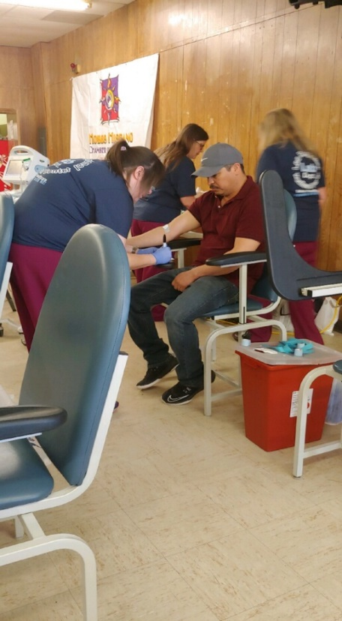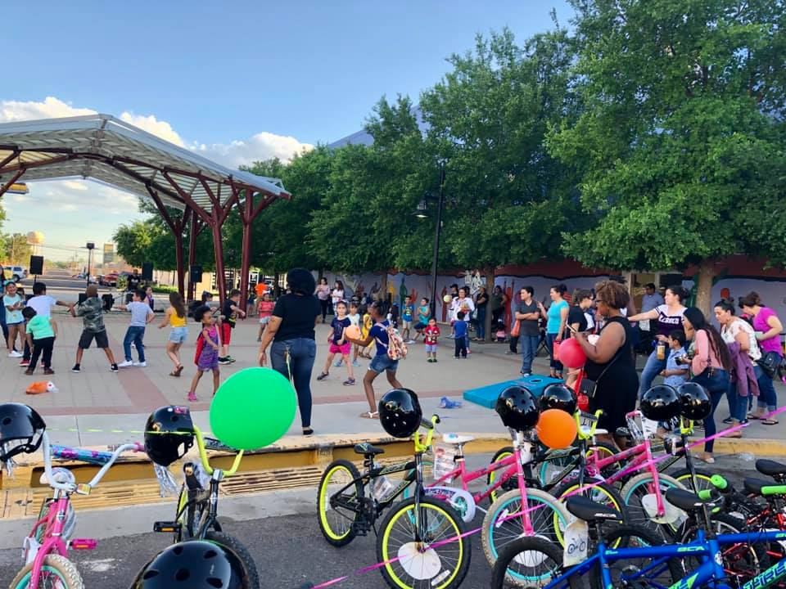

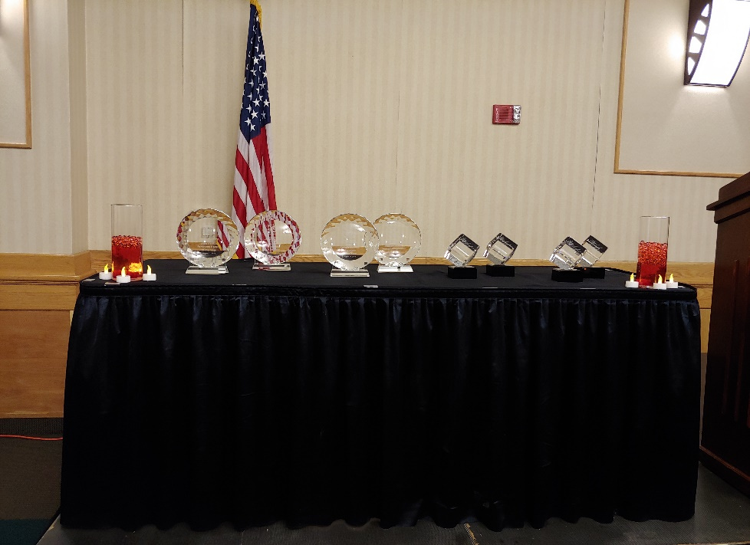

In conjunction with The Hobbs Hispano Chamber of Commerce Foundation we assist with the Fiestas de Septiembre and Mariachi Christmas.
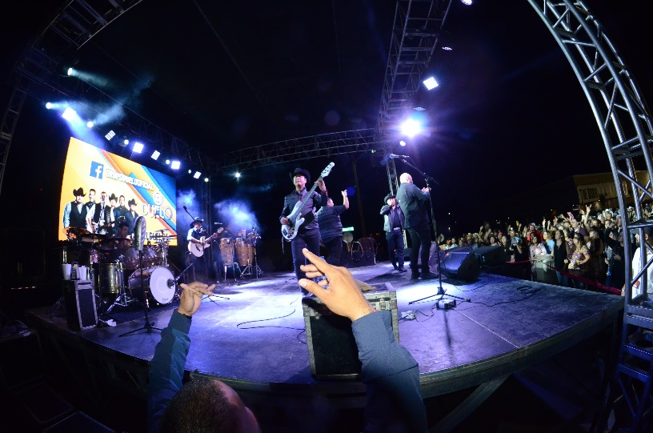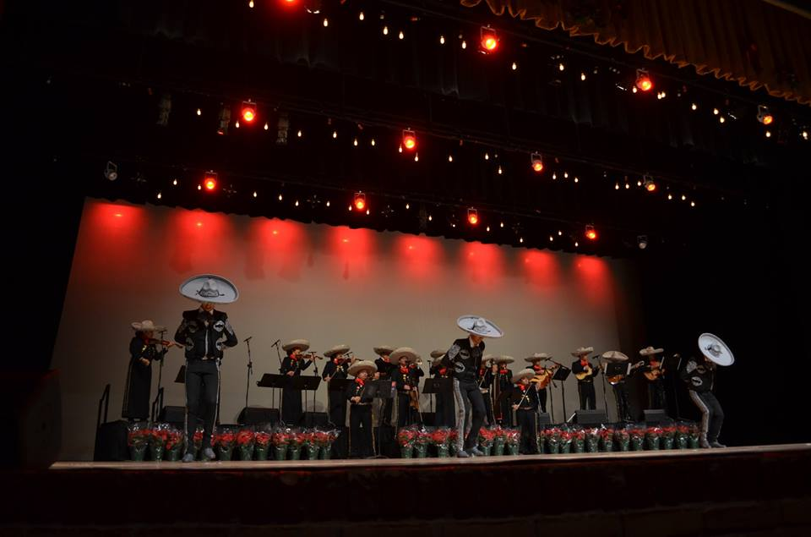

Pan Dulce y Café:
Our event Pan Dulce y Café (Sweet Bread and Coffee) is tradition here at The Hobbs Hispano Chamber of Commerce. It gives our members an opportunity to network with members/attendee’s. As a member you can host a Pan Dulce y Café (OPTIONAL) or just simply attend one.

High School Graduate Scholarships:
The Hobbs Hispano Chamber of Commerce Foundation provides scholarships to high school seniors by raising funds from the events Fiestas de Septiembre and Mariachi Christmas. This year of 2019, nine high school seniors were given a scholarship. We take pride in being able to provide students the opportunity to attend college.

Senior Packets:
The Hobbs Hispano Chamber of Commerce will provide graduation cap, gown, and tassel to high school students that need help purchasing them.

On behalf of the Board of Directors and the membership, I extend to you an invitation to become a member of the Hobbs Hispano Chamber of Commerce.

Kindest Regards,
Joann Jurado
Rep of Member Relations

Membership Application

[ ] New Membership [ ] Renewal

Please type or print only
MEMBER INFORMATION

*Business Name: Referred By:
*Mailing Address: City, State, Zip:
*Physical Address: City, State, Zip:
*Phone: Fax: *Business Email:
*Type of Business: *Date Established:
*Website: *Facebook: Other:
Number of Employees: *Information will appear in Online Chamber Member Directory
OWNER

Prefix: First Name: Last Name:

Title: Direct Phone: Email:
PRIMARY CONTACT

Prefix: First Name: Last Name:

Title: Direct Phone: Email:
TELL US ABOUT YOUR BUSINESS
HOW DID YOU HEAR ABOUT THE HHCC?

Radio | HHCC Member | Friend
Newspaper | Business | Other:

CHAMBER INVOLVEMENT

How can the Chamber best serve your needs?

Are you interested in volunteering?

Would you be interested in hosting a Pan Dulce y Café (Networking event)?
Would you like to receive text message notifications? ______ Cell phone number: _______________________________

Any Suggestions?
MEMBERSHIP CATEGORIES

Membership Levels Membership levels are based on your number of employees and/or your desired level of commitment to the mission of the Hobbs Hispano Chamber of Commerce.
Business Level: 1-5 Employees | $100.00 | Individual: | $50.00
Business Level II: 6-49 Employees | $250.00 | Non-Profit Agency: | $100.00
Executive Level: 50 or greater Employees | $500.00 | Institution of Higher Learning: | $500.00
Corporate | $1,000.00 | Community Partner: | $5,000.00
Community Partner Non-Profit | $2,500.00

Total Membership Investment:
PAYMENT METHOD

Send Invoice | Check Enclosed
Date: | Date:

*Please make checks payable to the Hobbs Hispano Chamber of Commerce
All Business and individual members are eligible to participate in various Hispanic Chamber Committees. Your company or yourself may be represented by actively participating in any of the following committee service interest: Membership, Events, Education. For more information on each committee and meeting dates, please contact the HHCC office listed below.
Please send business cards and brochures to the HHCC office so we may proudly display them in our office lobby. If you have any questions, please contact our office.

IMPORTANT NOTICE
I understand that membership in the Hobbs Hispano Chamber of Commerce constitutes my express invitation or permission for the chamber to transmit by telephone facsimile machine to the number(s) I’ve provided above, e-mail or written materials, including but not limited to those relating to property, goods, services, events, meetings or notices, and the availability thereof. I also understand that these will be published in the chamber’s membership directories, excluding those I’ve checked in the box(es):
Signature
Date

Telephone | Fax | Email

Please contact our Rep OF Member Relations if you have any questions: Joann Jurado
Email: Membership@hispanochamber.org Office: 575.393.1030

Please return completed application to HHCC: Membership Services
113 North Shipp Street Hobbs, New Mexico 88240
Office: 575.393.1030 Fax: 575.393.103
www.hispanochamber.org

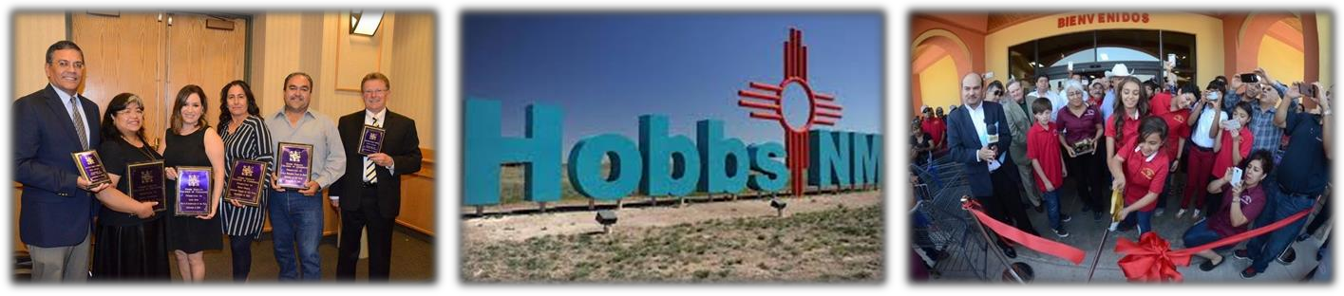

….Where Business & Opportunity Meet
HOBBS HISPANO CHAMBER OF COMMERCE BOARD OF DIRECTORS & STAFF

Hobbs Hispano Chamber Board of Directors

Rosa Carrilo, Alex Molinar
President Member
Got Safety Farmers Insurance

Armando Ornelas
Vice President Member
State Farm

Susana Arvizu, Hobbs Hispano Chamber Foundation directors
Secretary
State Farm Oscar Gonzales
President
Ezequiel Rodriguez Omg Printing
Treasurer
Rose B. Scott,
Rosa Smith, Past President
Nuclear waste
Member Partnership
Noalmark Broadcasting
Alberto Caballero
Sergio Polanco, Member
Member Entrench Inc.
Wellsfargo
Lariz Ortiz
Rachel Moon, Member
Member Entrench Inc.
Zia Park Casino &
Racetrack Hobbs Hispano Chamber Staff

Laura Davis Laura Barrios Joann Jurado
Member Business Administration Rep of Member relations
United Realty Manager

